With the announcement that the Russia v Scotland match would take place in Moscow, we got to work utilising various streams on shortlisting charities to be the recipient of our donation. Through our own research and suggestions, following an extremely tough decision, the Lighthouse Children’s Hospice was selected.

The Lighthouse Children’s Hospice is a medical charity, and received no government funding. They are fully reliant on the donations from thousands of individuals every year. The hospice is to help and support children with incurable illnesses, including supporting children with incurable illnesses, but can still be given love and care.

The charity was in progress of building a new hospital in the Moscow area and in the final steps of being completed, with the objective of obtaining full medical licences in early 2020. The intention being, to try to ease the pain, make dreams come true, and bring joy into the lives of the children and their families, no matter how much or little time there is left. The hospice supports around 600 children and with the many needs and requirements, cannot always offer the full support required. Whilst the hospice was not yet in a position to offer medical procedures, a number of support services were already being carried out in the hospital, including consultations between doctors, children and families, training for parents, equipment support such as wheelchair fitting, as well as the administration, fundraising, and accounting operations.

Through the British Embassy in Moscow, (to assist with the language barrier) and make the initial introductions, we were put in touch with Olga Savelyeva, one of the Philanthropy Managers within the hospice, where we were invited to tour the new facility on the morning on the match.

After meeting in the local Starbucks, a group of 8 of us from the Sunshine Appeal, along with guests from the Embassy, were taken a short walk through a residential area and into the hospice grounds, hidden away at the end of a small street. The area outside was full of colour and activity space for the children to spend, not just the usual plain sterile environment usually associated with hospitals. Olga and her team welcomed, and gave us some background and detail on the history of the charity, before beginning our tour.

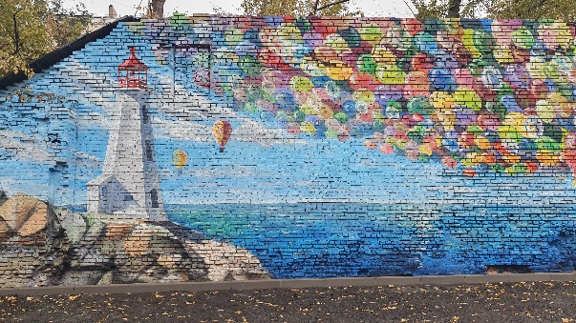
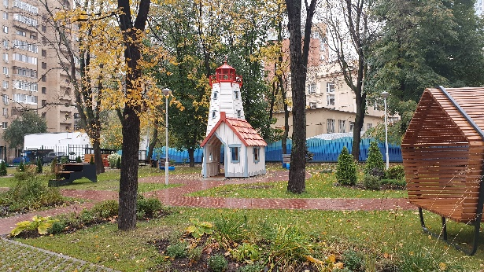
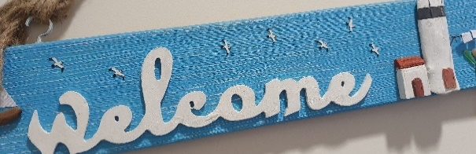

We were taken around a number of areas where when fully operational, would be used on a daily basis. We met a young boy in having his wheelchair adjusted, and separately a young girl and her mother discussing some support equipment being provided with a physiotherapist. Our tour took us into a pool area specially designed to be used for physio and strengthening exercises, and then onto the next floor where there were separate stay over and kitchen areas. The intention of the hospice was not to be used for long stayovers – but perhaps only one or two nights at a time, so these areas were clean, comfortable, provided the facilities for those staying and the parent with them to be able to able to stay over comfortably, and safely. Everything was identifiable with clear pictures and labelling, with specific thought put in to the kitchen and play areas, and separate break out and chill out zones for the children.
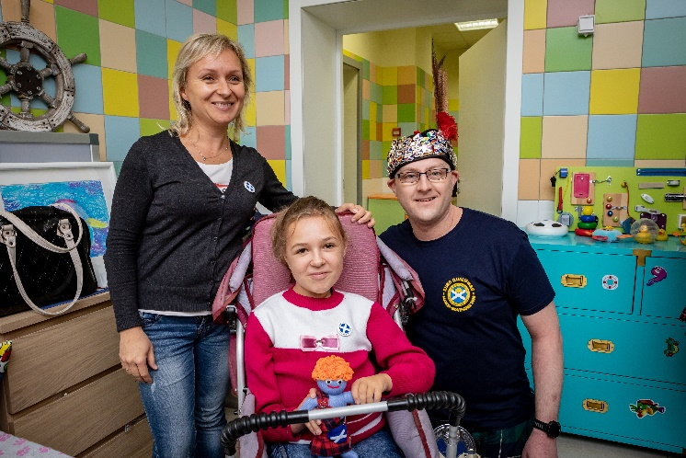
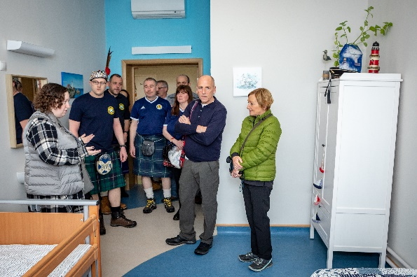
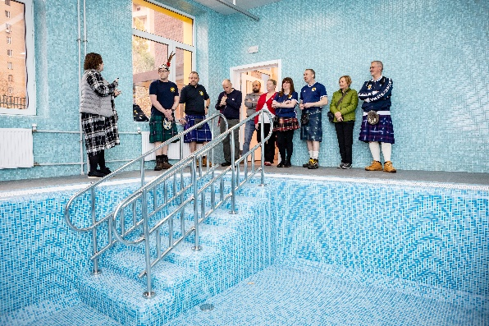

Obviously, one key realisation of the hospice was the sad fact that many of the children the centre helps, pass away far too early in life. Pictures photographs and stories remembering all of those the centre had helped were visible thorough the corridors. We were told a number of inspirational stories about how the hospice had helped, prolonged and made the lives of some children more comfortable whilst their illness to hold, with the provision of breathing equipment and ventilators, or wheelchairs. Photos of families enjoying their last days together or instances where the hospice allowed the parents access to their children in a safe environment – something not always allowed in Russian medical settings. Some of the stories inspirational, but at the same time heart-breaking.

As we continued round, we stopped in front of a special exhibition of photos: a young girl who expressed one of her final wishes was to become a photographer, and the hospice had arranged for not only the assistance with photography, but some models to visit the girl and bring her wish to life. Another set of photos, where a mother had showcased the beauty of a young girls smile despite the challenges of an incurable disease.
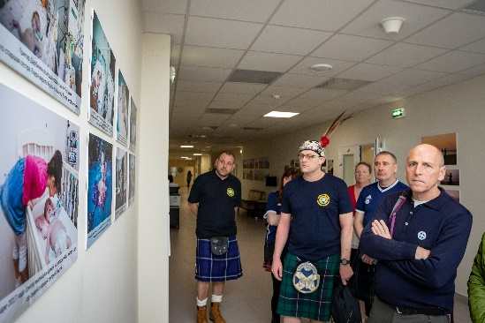
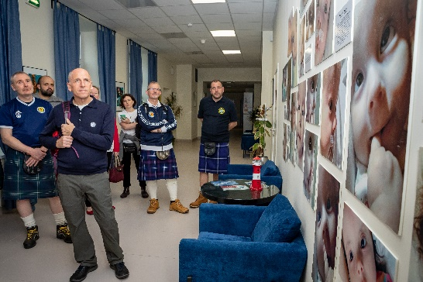
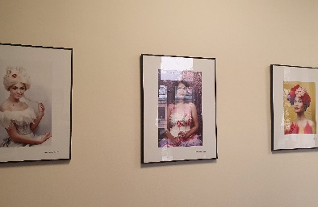

Our tour finished, and we returned to the main reception area to present a cheque for £5,000. The money from our donation was being put towards some of the required medical equipment ahead of the hospice being opened. We wished them well ahead of their intended opening in 2020. It really is an amazing facility with so much thought gone in to every aspect from design to layout to support functions on site.
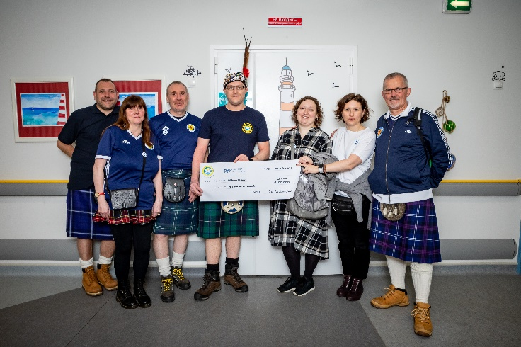

Whilst it’s difficult to visit such institutions, it’s a sad reality of the world we live in that these hospices are required, and although there is not going to be a happy ending with some of the children, the support and help the provide can give a bit of sunshine into a child’s life despite extremely challenging and unfortunate circumstances they are fighting against. It was a pleasure to donate to a truly inspiring organisation.
